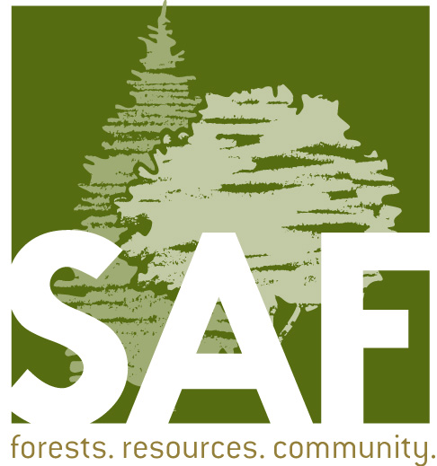
Membership Retention and Recruitment Actions
Version 1 (02.01.16)
This roadmap of membership activities is intended for state and chapter leaders so National office efforts are coordinated with all SAF units. Instructions on how to access membership rosters are also included, as are key membership contacts.

This plan of action is meant to be a basis for 2016 membership recruitment and retention efforts. It is a work in progress and is not a complete or final list. Suggestions and additions are encouraged to aid in the overall goals of member recruitment and retention. Please let us know if you have suggestions or additions.

ONGOING

When | What | Who
Monthly | Monthly leadership email – containing SAF news, membership updates and State Society membership rosters. Access anytime by going to the following link:  www.eforester.org/members/member_central.cfm  - Establish contact with new and reinstating members.  - Reach out to members who have yet to renew for 2016. These folks are highlighted in yellow on your respective membership reports.  - Follow-up on resignations to identify reason why and possible resolution. | Local Units: Chapter and State Society membership chairs and/or chairs.
Monthly | Student members join SAF’s LinkedIn page to keep up-to-date on what is happening in the workforce and job postings. It is also a great way to stay in contact with past student members that have moved or changed their contact information. | Students (with reminder from student leaders)

JANUARY 2016
When | What | Who
Jan 14 | Emails sent – 10th notice to renew 2016 membership online.  “We’ve extended your benefits.” | National Office staff
Jan 14 | Invoices mailed – 11th notice to renew 2016 membership.  Stamped “PAST DUE” on the inside of the invoice. | National Office staff

FEBRUARY 2016
When | What | Who
Feb 3 | Lapsed members call campaign begins. This campaign will reach out to lapsed members (2015-2013) offering option to renew membership. | National Office staff
Feb 25 | Invoices mailed – 12th notice to renew 2016 membership.  Stamped “PAST DUE” on the inside of the invoice and “URGENT” on the outside of the envelope. | National Office staff

MARCH 2016
When | What | Who
March 9 | Emails sent – 13th notice to renew 2016 membership online.  “Time is running out!” | National Office staff
March 25 | Emails sent – 14th notice to renew 2016 membership online.  “Only one week left to renew.” | National Office staff
March 31 | Email sent – 15th notice to renew 2016 membership online.  “Last day to renew.” | National Office staff
APRIL 2016
When | What | Who
April 1 | Emails sent - ## notice to renew 2016 membership online.  “Membership benefits have expired.” | National Office staff
April 1 | Members who have not renewed their membership for 2016 go on “inactive” status. These folks do not receive any services after this date and remain highlighted on monthly membership rosters so local unit leadership can make personal contacts with them. | State Society and Chapter leaders
April 11 | Lapsed member survey sent to 2015 lapsed members who have yet to renew for 2016. This survey is designed to get to the heart of why these past members chose to not renew their membership and provide a friendly reminder that membership was not renewed. This will be sent via email. | National Office staff
April-May-June | Graduating students should keep in touch with SAF and update their profile online. | Student members (leaders provide reminder)

Fall 2016 information will be available later in the year.

STATE SOCIETY AND CHAPTER MEMBERSHIP REPORTS
Membership reports are updated monthly on the national website at Membership Central: http://www.eforester.org/members/member_central.cfm. The easiest way to access this page is to bookmark this link, then use it to access the SAF website. First you must log in as a member, then you can go to this bookmark and click on it a second time to navigate to this page.
Another way to get there is from the SAF national website home page, click on the "Local Units" picture/link at the top of the home page, then click on the white wording "Membership Reports."
Three membership reports are provided for each state society.

- Click on your state society, for example, ORSAF for the Oregon Society. The title on the report itself is “SAF Chapter Changes.” It is a pdf document showing membership changes during the last month. Most of the columns and pages are self-explanatory.
- Roster. This is a spreadsheet showing full membership contact information. Members who have not yet paid their membership dues are highlighted in yellow and orange by lapsed date. The excel spreadsheet can be sorted by chapter or other fields.

MEMBERSHIP CONTACTS

National Office:
Corey Ruple
Director, Member Services
1-866-897-8720 x114, ruplec@safnet.org

Membership Services – Customer Service
1-866-897-8720 x100, membership@safnet.org

SAF Northwest Office:
Lori Rasor, 503-224-8046, rasor@safnwo.org
Amanda Mattern, amanda@forestry.org

Oregon SAF Membership Chair:
Jim Culbert, jhculbert@gmail.com

WSSAF Membership Chair:
Don Hanley, dhanley618@gmail.com

Inland Empire SAF Membership Chair:
Steve McConnell
509-477-2175, smcconnell@spokanecounty.org

